

ELB17S
Entry Level Bioinformatics
06-10 November 2017

(First 2017 run of this Course)

Basic Bioinformatics Sessions

Practical 3: Database Searching

Sunday 15 October 2017
Searching for sequence similarities in databases.
The most popular way to investigate a sequence has always been to compare it with one of the sequence databases now accessible from sites all over the world. When sequences databases were more sparsely populated than now, the objective was to search hopefully, not always with success, for any convincingly similar sequence(s). When such a match was discovered, it could be supposed that known properties of the “similar” database sequence might provide insight to the properties of the query sequence. Now, the databases are full of sequences representative of most interesting conditions. Similarity searches are conducted in the expectation of finding many close “hits” for almost any sequence. Fewer database searches are conducted in complete ignorance of what the query sequence might be.
Here, take the PAX6 genomic DNA sequence retrieved from Ensembl and conduct two searches analogous to those run in the Ensembl pipeline (or the equivalent NCBI pipeline for Map Viewer). Results should confirm that which has already been discovered using other sources.
blast is not the only sequence database searching program available, but it is the most popular by a very long way. blast searches are offered in many forms by many servers all over the world, but the most comprehensive and reliable service has to be that offered by the NCBI.
Go to the NCBI homepage at:
http://ncbi.nlm.nih.gov

Select the BLAST option (from the Popular Resources list). In the Basic BLAST section, select nucleotide blast. Use the Enter Query Sequence Browse (or Choose File) button to upload the file:
pax6_genomic.fasta.
For results like those used by Ensembl to predict PAX6 transcripts, you must compare your genomic sequence to a reliable set of human mRNA/cDNA (or similar) sequences.
In the Choose Search Set section, set the Database to Reference RNA sequences (refeseq_rna).
You are now able to specify an Organism, choose human (taxid:9606).
blast is now set to compare the PAX6 genomic region with all Human mRNA sequences in RefSeq.
Note that the default Program Selection is Highly similar sequences (megablast), which seems appropriate here as all the mRNA that correctly match should surely do so almost perfectly.
Click on the Algorithm Parameters button. The defaults are fine here, but before starting your search, try changing the Program Selection and observing the different Algorithm Parameters.

The default settings of all shared parameters are identical for the two slower more sensitive Program Selections.
There are differences for megablast, where speed is of the essence and sensitivity can be sacrificed.
Smaller Word sizes slow searches but increase sensitivity. For megablast the default Word size is 28 otherwise it is 11.
Gapped alignment is time consuming and, by default, considered more crudely by megablast than the other two algorithms.
Filtering and Masking matches with organism specific repeats and/or low complexity regions takes time, and so only avoiding Low complexity regions is on by default for all Program Selections.

When discontinuous megablast is selected, an extra options section appears. Discussing how this flavour of blast works is a little beyond the scope of these note, but briefly. Unlike the other Program Selections, discontinuous megablast does not just look for exactly matching “words” of given size as a first step towards identifying matching regions between sequences. It looks for a pattern of matching bases within a word. For example, the default choice assumes your query is coding and looks for 11 matching bases within a word of 18. Approximately, every third base is allowed not to match. Biologically, this can be justified as allowing for third codon position wobble. For more detail, use the appropriatebutton. Notice there arebuttons by every parameter selection. Try one or two. In the process, discover:
When would Mask lower case letters be a useful thing to do?

Automatically adjust parameters for short input sequences is independent of Program selection, and so remains unaltered.
Which parameters would blast need to automatically adjust to cater for short input sequences (such as primers being tested for uniqueness), and why?

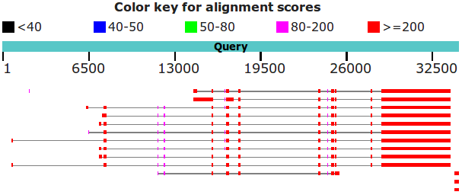
Finally, ensure all the parameter defaults are back in place and that megablast is the Program Selection, ask blast to Show results in a new window and then click on the button. Impressively swiftly, you will have results. At the top of which will be a graphical overview.
This graphic implies that there are 11 full length matches between the genomic sequence and mRNAs in RefSeq. The RefSeq entries had to be “gapped” in order to compensate for the introns that are represented in the genomic sequence but not in the mRNA sequences. The red blocks therefore represent very closely matching (brownie points) exons, the lines joining the red blocks represent introns that have been spliced out. All 11 full length hits match reasonably uniformly except for the first few exons, implying significant variation in the 5´ UTR.
Why do you suppose that a few of the exons of the first 11 matches do not achieve the maximum score?

Explain why one exon in the reasonably consistent region, does not appear in all of the transcript matches?

In a previous Practical, you discovered directly that there were 11 high quality “NM_” PAX6 transcripts in RefSeq.
Until recently, there was a further 9 “XM_” PREDICTED transcripts. However, in the last release of RefSeq, the 9 less reliable XM_ transcripts were removed and so were not detected by blast. Ensembl claimed to have used most, if not all, the high quality NM_ RefSeq sequences to aid its transcript predictions. Ensembl would have ignored the XM_ PREDICTED RefSeq sequences even if they still existed.
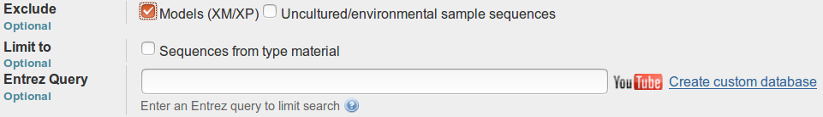
blast just sees sequences and, by default, will not be influenced by the quality of the support for their existence. Run as in this exercise, blast would always report all RefSeq PAX6 mRNAs matching the PAX6 genomic region convincingly, independently of how questionably they are evidenced. However, you could have filtered the target database(s) in various ways, including choosing to Exclude all Modules(XM/XP) (that is all the more questionable mrna sequences and their amino acid translations). This would not be appropriate here as we wish to mimic the approach of the NCBI genome databases which DO consider XM/XP sequences should they exist.
There is a point to pursuing all this detail. You reference a collection of interdependent databases, all of which are updated regularly. More often than not you will notice inconsistencies due to asynchronous updates and differences in database management/interpretation policy. A small price to pay for such a rich source of information, but one of which I suggest it is wise to be aware.
The message of the particular blast search here is that it is so easy to predict the same PAX6 transcripts as you discovered in MapViewer, just with a simple blast search. That is, you can look things up, or work most of it out for yourself.
If you hover over the graphical hits, their origin will be displayed above the graphic.
Below the Graphic Summary are the Descriptions, a simple list of the 15 matches represented in the graphic.
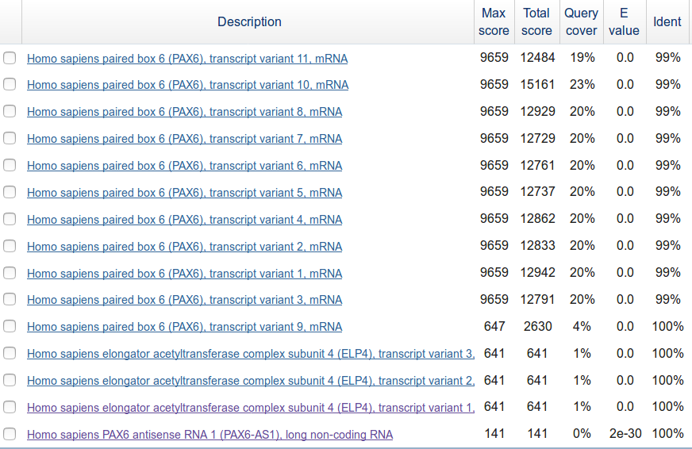
These are such that:
- The top 11 hits, corresponding to the 11 full length hits of the Graphic Summary, are the quality (i.e. NM_ entries with good supporting evidence) RefSeq transcripts.
- There follows, corresponding to the 3 small red blobs in the extreme bottom right of the Graphic Summary, 3 hits that are the ends of mRNAs for the ELP4 gene. They are exactly where you should expect them to be, assuming you paid full attention to the ELP4 transcript predictions shown in both the Ensembl and Map Viewer displays of the Genomic region around PAX6. Reject these contemptuously, they do not pertain to our investigation of PAX6.
- The 15th match, corresponding to the barely visible tiny smudge match to the left of the top Graphic Summary hit, is recorded as “uncharacterized” and fails to fit in with my story, so I ignore it!
So, this blast search suggests the existence of 11 PAX6 transcripts supported by RefSeq data, as is reported by Map Viewer. Also, the results are broadly consistent with the information discovered in Ensembl.
Which of the Refseq PAX6 transcripts corresponds to isoform 5a?

Moving further down the results you will come to the alignments between the PAX6 genomic sequence and the matching database entries. All similarity searches use local alignment strategies, so you should not be surprised to see a number of alignments for each “hit” in the list. Here we have a genomic query sequence aligned exclusively with mRNA sequences from RefSeq. The expectation is therefore to find an alignments corresponding to exons. The alignments are ordered by quality, though you are provided with a Sort by: menu to alter the order to taste.
Look at the first alignment for the best matching PAX6 transcript. It is the alignment of the very last exon of a RefSeq transcript with the end of the gene you exported from Ensembl.
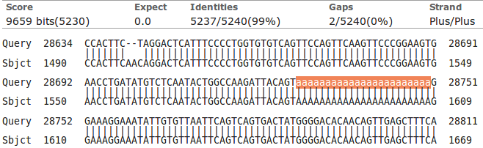
Notice the lower case string of 'a's. The case indicates that they were ignored (filtered) as a Low complexity region whilst megablast was looking for identically matching words that might suggest matching regions. By themselves, the 'a's are not sufficient evidence that a biological match exists. Only because the surrounding sequence is compellingly similar, can it be assumed that such a match does exist. The 'a's are replaced (lower case to indicate they were filtered) when the final alignment is computed. If you look a little further down the same alignment, you will see several other runs of 'a's and 't's for which the same explanation applies.
Now use a version of blast (called blastx) to compare your genomic sequence with a protein database. blastx will translate a DNA query sequence in all six reading frames and compare each translation with a protein sequence database. Thus, in a similar fashion to that employed by the Ensembl pipeline, protein coding regions of the genomic DNA can be identified. For clarity, we will use only the well annotated human proteins of the SwissProt section of Uniprot. First go to the home of blast at:
http://blast.ncbi.nlm.nih.gov/Blast.cgi
Select. Use the Enter Query Sequence Browse (or Choose File) button to upload file pax6_genomic.fasta.
In the Choose Search Set section, set the Database to UniProtKB/Swiss-prot prot(swissprot). Specify the Organism as human (taxid:9606).
Take a look at the Algorithm parameters.
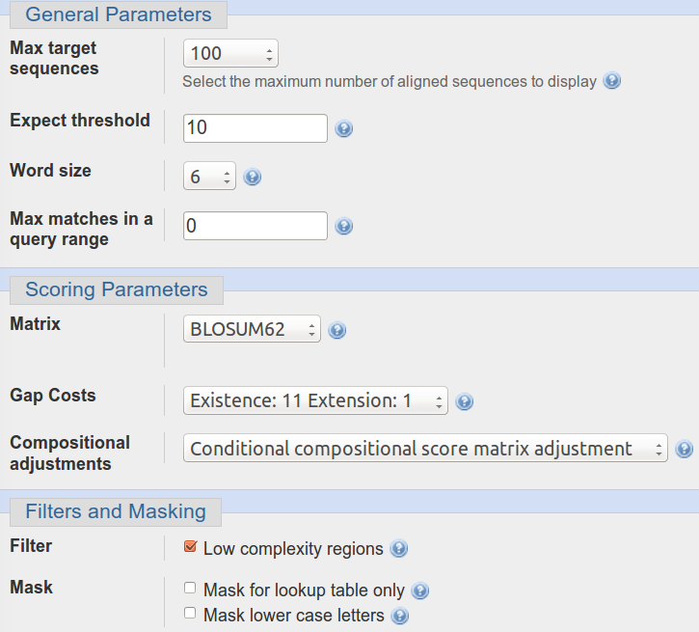
The Word size choice is 2, 3 or 6 . The default is 6. We seek very close matches here, so the largest Word size would seem appropriate.
The default scoring matrix is BLOSUM62, but choices from both the BLOSUM and PAM families are offered.
The Compositional adjustments parameter offers the opportunity to refine the chosen scoring matrix to reflect the residue composition of the sequences being compared in one of a number of ways. Click on the relevantbutton for further enlightenment. I must admit, I was left with questions after reading the Help, but some attempt to customise the evaluation of an alignment to reflect sequence composition does seem like an excellent idea.
Low complexity regions will be filtered by default.

Change nothing other than to ask blast to Show results in a new window and click the button.
After minimal thought, blastx will thrust its conclusions before you. Hover over the graphical hits for identification.
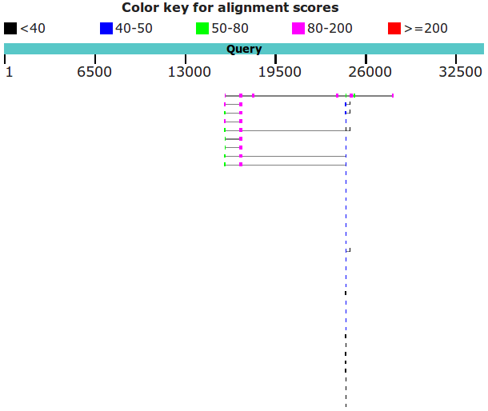
What are the 9 strongest matches around base position 16,750?
Why would you expect exactly 9 matches around this point?
What do you make of the plethora of matches around 24,000?
Move down to the textual list of the matches. Hopefully as you fully expected you will find the expected number of Paired box matches at the top of the list followed by many many Homeobox matches.
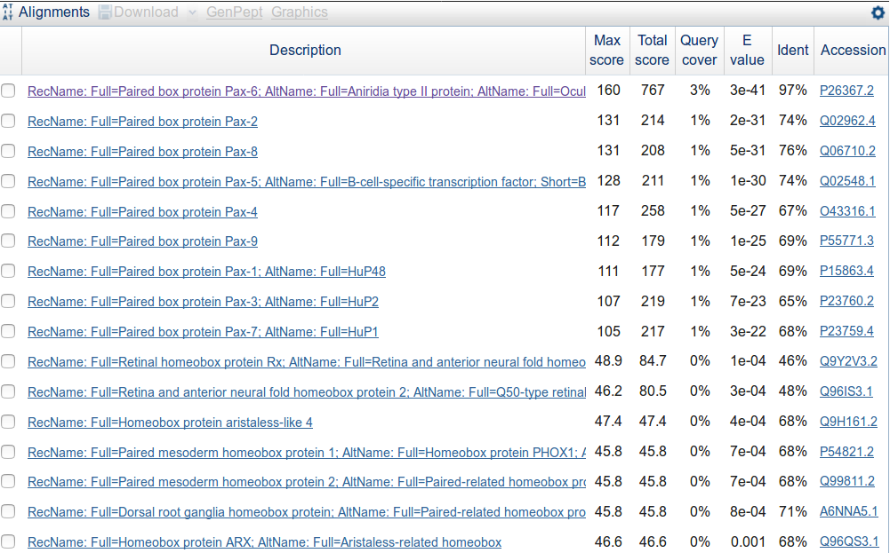
Why do you suppose the Paired box matches precede the Homeobox matches?
How do you suppose the Max matches in a query range parameter might be of value if this order was reversed?

Take a look at the alignments. You will see many places where regions have been filtered as non-informative. I suggest the one illustrated was filtered because it would match anywhere that was sufficiently Serine rich.
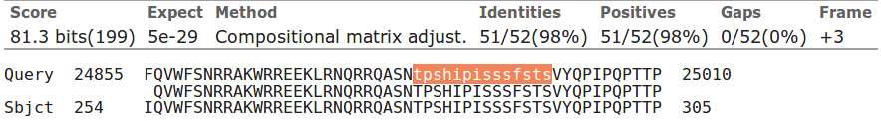
How does this “non-informative” region match expectations suggested by SMART and the Feature table of UniprotKB for PAX6_HUMAN?

THE END
DPJ – 2016.10.15
Model Answers to Questions in the Instructions Text.
Notes:
For the most part, these “Model Answers” just provide the reactions/solutions I hoped you would work out for yourselves. However, sometime I have tried to offer a bit more background and material for thought? Occasionally, I have rambled off into some rather self indulgent investigations that even I would not want to try and justify as pertinent to the objective of these exercises. I like to keep these meanders, as they help and entertain me, but I wish to warn you to only take regard of them if you are feeling particularly strong and have time to burn. Certainly not a good idea to indulge here during a time constrained course event!
Where things have got extreme, I am going to make two versions of the answer. One starting:
Summary:
Which has the answer with only a reasonably digestible volume of deep thought. Read this one.
The other will start:
Full Answer:
Beware of entering here! I do not hold back. Nothing complicated, but it will be long and full of pedantry.
This makes the Model answers section very big. BUT, it is not intended for printing or for reading serially, so I submit, being long and wordy does not matter. Feel free to disagree.
From your investigations of Searching for sequence similarities in databases
When would Mask lower case letters be a useful thing to do?
Generally, whenever one might suspect the automatic masking algorithms of blast might miss a non informative region in a specific query sequence, obviously.
A specific example might be when a query sequence contained a significant informative region that was known to be common amongst the sequences being searched. If this region was left unmasked, blast would pick up so many similar matches to this one region that other interesting similarities might be obscured. By manually masking such a region by changing it to lower case, its matches would not be seen by blast and matches with other regions of the query sequence should be more apparent.
Which parameters would blast need to automatically adjust to cater for short input sequences (such as primers being tested for uniqueness), and why?
The word size: Clearly, if you are trying to find matches for a primer (for example) of around 20 base pairs, it would be pretty silly to use a word size of 28 (default for megablast). A word the same size as the primer would find only exact matches. A word of about 7 would allow a couple of mismatches and would probably be most generally appropriate.
The expect score: As good chance matches between between a short query sequence and a large database will be abundant, it would not be sensible to choose a demanding (i.e. small) expect score to represent the limit of significance. In particular, a primer sized query sequence of around 20 base pairs might easily exactly match more than 10 times (generally the default maximum expect score for a significant match) just by chance. After all, there are only 4 bases, a string of 20 is not that long and the databases can be huge! Typically blast chooses very high expect score cut off for short query sequences, effectively removing the expect score filter altogether.
Earlier versions of blast did not automatically adjust these parameters. When a short query sequences were selected, suitable adjustment was left to the user. Without sensible parameter adjustment, results could be greatly confusing. For example, a 21 base pair primer could easily match perfectly more than 10 times against a large DNA sequence database. blast is set to ignore matches that are expected to occur more than 10 times by chance. Thus even exact matches with such a small sequences would be ignored! Now automatic parameter adjustment is undertaken by blast, the user does not really have to think too hard. However, it does seem to be a good idea to know what blast is doing and why.
Why do you suppose that a few of the exons of the first 11 matches do not achieve the maximum score?
Summary:
Each local region of significant alignment between a database entry and a query sequence is scored independently. The scoring method that governs the alignment score colour in this graphic, reflects both the quality of the match and its length. Unless a particular region is of sufficient length, it cannot achieve the 200 bit threshold even if the alignment is perfect. Note that it is the shorter regions that fail to reach thestatus. All of the illustrated local alignments associated with PAX6 transcripts are essentially perfect.
Full Answer:
In common with most database searching programs, blast compares query sequences with database entries using a local strategy. The overall evaluation of a particular query sequence is taken to be the highest local score.
Individual local matches are coloured according to individual quality. In this query, all true matches should be perfect, or very nearly so. Scores might therefore be expected to be maximal (). However, they are not? Some only score in the range .
The score referenced for this purpose is the bit score. For a full, no holds barred definition of this score, try here. I prefer this somewhat gentler version:
“The bit score gives an indication of how good the alignment is; the higher the score, the better the alignment. In general terms, this score is calculated from a formula that takes into account the alignment of similar or identical residues, as well as any gaps introduced to align the sequences. A key element in this calculation is the “substitution matrix ”, which assigns a score for aligning any possible pair of residues. The BLOSUM62 matrix is the default for most BLAST programs, the exceptions being blastn and MegaBLAST (programs that perform nucleotide–nucleotide comparisons and hence do not use protein-specific matrices). Bit scores are normalized, which means that the bit scores from different alignments can be compared, even if different scoring matrices have been used.”
Still too scary? The important things to note are that:
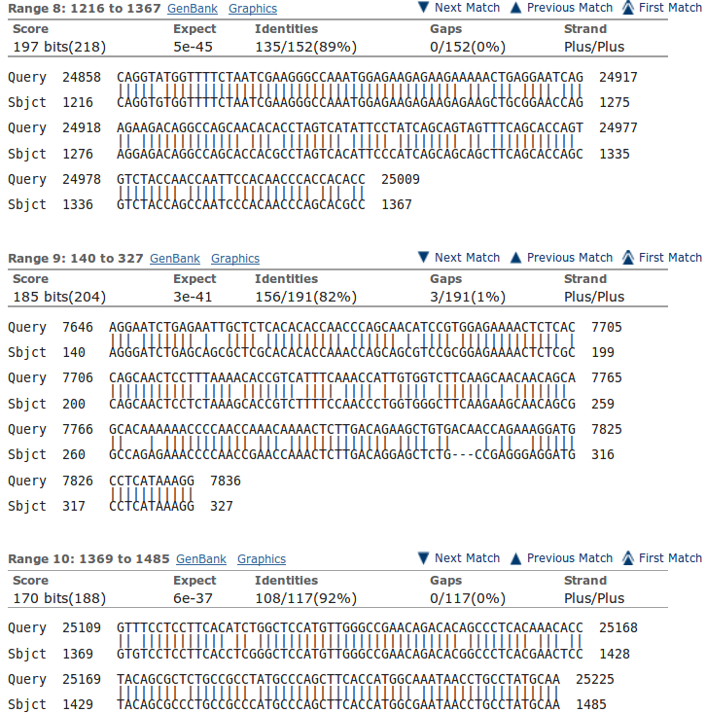
- These scores are based on a simple DNA scoring matrix (1 for a match, -2 for a mismatch by default for megablast), plus penalties for gaps. So scores will be limited by the length of the alignment, ignoring gaps.
- The scores reflect penalties for indels (insertions or deletions).
- The scores are normalised so that they do not depend on the chosen scoring matrix. This allows bits scores from searches using different scoring matrices to be compared.
Both the scoring matrix dependant raw scores and the bit scores reflect both the length of an alignment and its quality. blast presents the local high scoring regions it discovers ranked by bit score. In general, this corresponds to length order. However, a shorter high quality alignment can occasionally outscore a longer less perfect alignment (as illustrated).
To obtain this illustration I had to use the more sensitive blastn algorithm to find more distant alignments (megablast is only going to notice really obvious matches) and remove the organism filter to insure that there were less obvious matches to find (all significant matches between any part of the human genome and any human mrna will be too uniformly near exact).
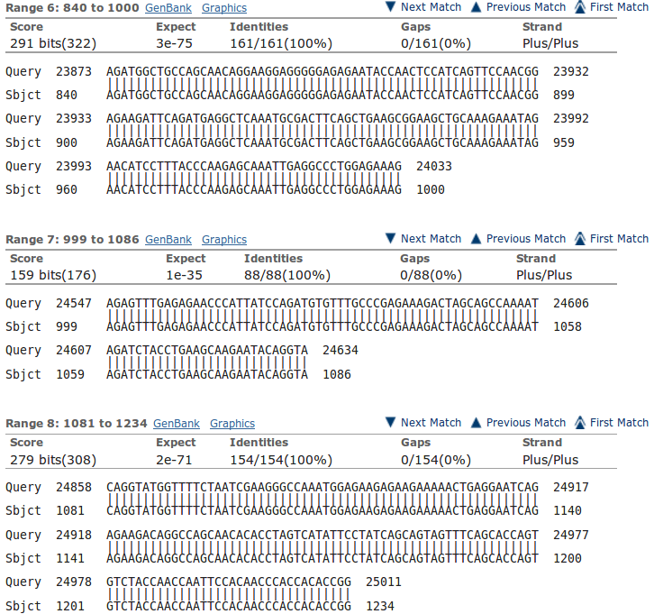
You can see evidence of what is occurring in the alignments further down your results. Here is illustrated one of the exons that occur in all transcripts at position 24,547. The match is perfect, but the length of the exon is consistently just to short to get to the heady level. To make this illustration represent alignments from a particular region, I set Sort by: (top of the alignments) to Query start position. If you look back at the blast graphic, you should be able to easily spot the region of these aligned regions including the one that is.
Note how imperfectly blast finds exon/intron boundaries. If the start of an intron happens to match the start of the next exon, blast will included the bases in two alignments. It is not looking for exons and introns as was spline, it just mindlessly seeks matches.

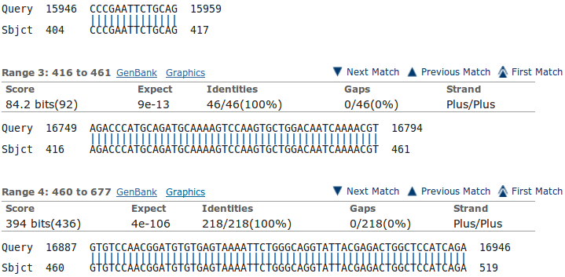
For a further example, look at the exon that is found only in the isoform 5a transcripts. It is tiny (42 base pairs) and scores well below even thought it is a perfect match.
Note that the alignment is 46 base pairs long due to blast adding on two bases either side that are actually the highly conserved intron start and end base pairs. As you can see, these extra base pairs occur in the preceding and succeeding alignment also.
Explain why one exon in the reasonably consistent region, does not appear in all of the transcript matches?
Well I refer to the isoform 5a exon, of course. The tiny inconsistent one about 9 exons in from the right (when it exists). This will, clearly, only occur in isoform 5a transcripts.
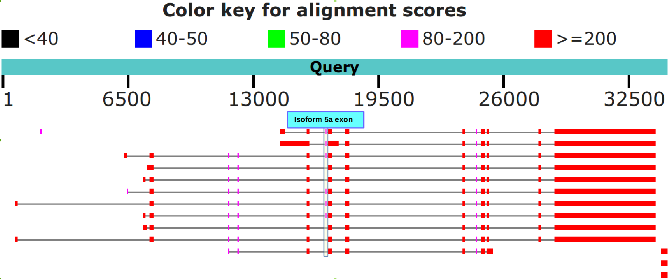

Which of the Refseq PAX6 transcripts corresponds to isoform 5a?
Summary:
As I am sure you are tired of noting by now, all the transcripts with the extra tiny exon around position 16,750 in the genomic sequence are isoform 5a transcripts. See the illustration for the previous answer.
Full Answer:
The isoform 5a transcripts can be spotted most easily from the graphic. They are the ones with the extra small exon slightly to the left of middle (around base position 16,750). For example, the first, second and third blast matches displayed. If you hover over all the full length matches with your mouse, you will see that they are transcript variants 11, 10, 8, 7, 6, 5, 4, 2, 1, 3 and 9 (in the vertical order of the graphic).
Stated with the unequalled poetry of RefSeq Accession Code and lyrical Title Line, the list of those with the extra exon becomes:
TITLE ACCESSION CODE
Homo sapiens paired box 6 (PAX6), transcript variant 11, mRNA NM_001310161.1
Homo sapiens paired box 6 (PAX6), transcript variant 10, mRNA NM_001310160.1
Homo sapiens paired box 6 (PAX6), transcript variant 8, mRNA NM_001310158.1
Homo sapiens paired box 6 (PAX6), transcript variant 5, mRNA NM_001258463.1
Homo sapiens paired box 6 (PAX6), transcript variant 4, mRNA NM_001258462.1
Homo sapiens paired box 6 (PAX6), transcript variant 2, mRNA NM_001604.5
Yes well, that was fun? The message of the question was to ensure you could see how to spot the isoform 5a transcripts (again!), not to list them! But, never mind, doing so was in fine tune with the ennui of the moment.
What are the 9 strongest matches around base position 16,750?
Summary:
Matches between the regions of the PAX6 genomic region encoding the PAX6 Paired Box domain and SwissProt protein sequences representing human proteins including a Paired Box domain.
Why would you expect exactly 9 matches around this point?
Summary:
Because that is how many human proteins including a Paired Box domain are suggested to exist according to Interpro (as shown in a previous Practical). There is PAX6 plus its 8 paralogues, imaginatively all named:
PAX1, PAX2, PAX3, PAX4, PAX5, PAX6, PAX7, PAX8 & PAX9

What do you make of the plethora of matches around 24,000?
Summary:
These are matches between the regions of the PAX6 genomic region encoding the PAX6 Homeobox domain and SwissProt protein sequences representing human proteins including a Homeobox domain. As you discovered earlier from Interpro, there are lots of such proteins.
The thin line joining features implies that those features relate to the same database entry. Notice that 4 of the 9 proteins including a Paired box domain near the beginning, also include a Homeobox domain further along. This is exactly as was suggested by the SMART annotation you examined earlier.
Full Answer:
Well, a couple of graphics to reinforce what has already been claimed and make life more precise and colourful.
First, recall from UniProtKB the positions of the two domains in PAX6.
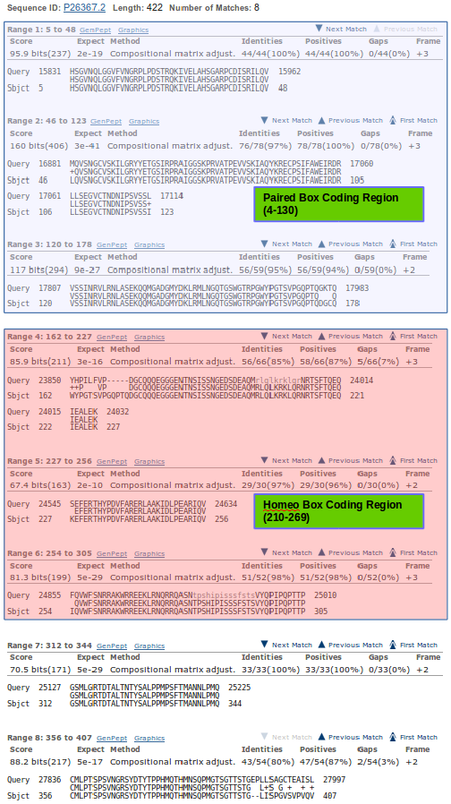
Next, order the blastx alignments by Subject start position.
Then see, from the first of the blastx alignments, it is the first 2 and a bit aligned regions that correspond to the Paired Box coding region.

The next 3 matching sections cover the whole of the HomeoBox coding region (with a fair overlap each side).

The final 2 matching sections are not involved in either domain.

With this understanding, one can decorate the blastx graphic in a fashion that makes the entirely obvious even MORE apparent than it was in the first place?
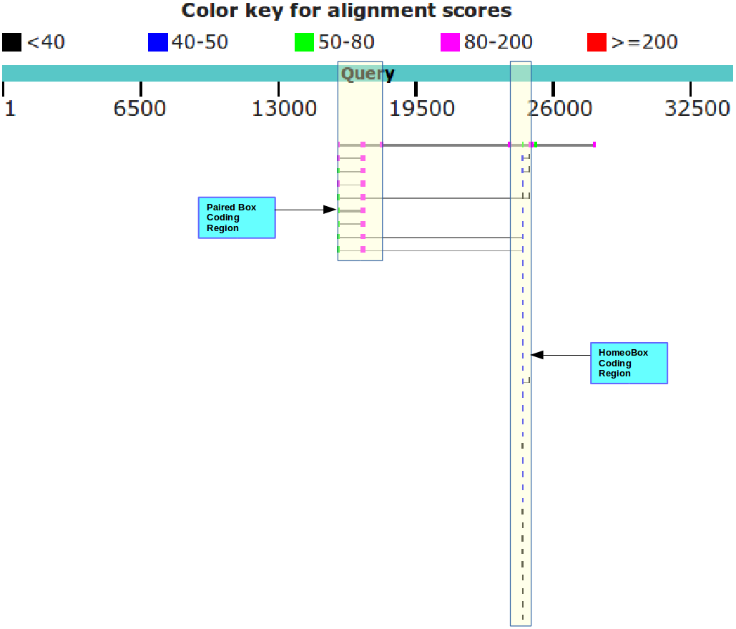
Well, I think it is a nice picture anyway.

Why do you suppose the Paired box matches precede the Homeobox matches?
Because they score more highly and so, in the opinion of blast, are more worthy. Primarily, they score more highly because they are longer. The list is ranked by E Value. Good matches with long sequence are less likely to occur by chance than equally good matches with shorter sequences.
Possibly a more interesting question might have been: “Why are not all the hits which include both domains at the top of the list?”. Surely they should be, as they match over a longer proportion of the query sequence and so must, in general at least, be of the greatest significance.
They do not always come at the top of the list because blast scores each matching region individually and uses the ranking scores associated with the single region with the highest E Value to evaluate the similarity of the entire database entry with the query. This has to be a dubious practice surely? But, it appears to work, so why complain.
To justify this last assertion, Look at your top hit.
E Val = 3e-41, Max score = 160, Total score 767 associated with the whole of P26367.2
Now look at the first few individual regional alignments for this hit.
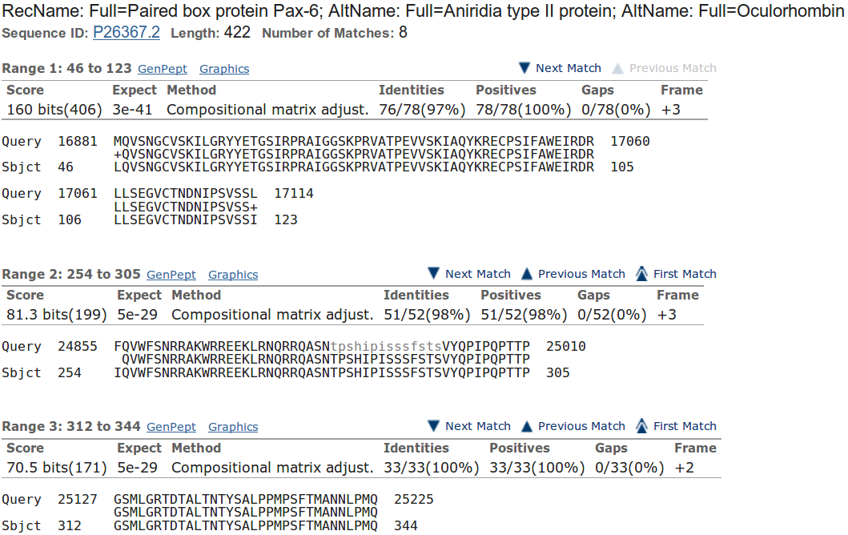
As you can see, the E Value and Max score values used to evaluate the whole protein were computed from just the best (ranked by E Value) local alignment! Crude, but never mind.

The Total score for the entire protein is the sum (rounded up to the nearest integer) of all the bit scores for all 8 local alignments computed for this protein (I suggest you just trust me on this assertion).
How do you suppose the Max matches in a query range parameter might be of value if this order was reversed?
If Paired boxes had been more prolific, then the number of Paired box matches might have filled the blast hit list before the highest scoring Homeo box hit was registered.
If Homeo boxes were longer, and so justified a better E value, then the number of Homeo box matches might have filled the blast hit list before the highest scoring Paired box hit was registered.
Either of these situations would be very unfortunate, but easily avoided by setting the Max matches in a query range parameter to something sensible (50 say). This would ensure that only the top 50 items in the blast hit list would be dominated by the strongest hit.
UNFORTUNATELY … although that is the intention of this parameter, it currently simply will not work, except in very particular circumstances, because of the way it is implemented. This is a great pity, because it is a very good idea, in principle.
I will spare you the details as, despite energetic debate, the NCBI people appear to have no intention of changing things, although they do appear to accept my arguments? Or maybe they just humour me?
How does this “non-informative” region match expectations suggested by SMART and the Feature table of UniprotKB for PAX6_HUMAN?
blast identifies two non-informative regions. I only discussed the prettiest one above. The region discussed is comprised largely of Serines, Prolines, Threonines & Isoleucines the 15 residues between 294-308.
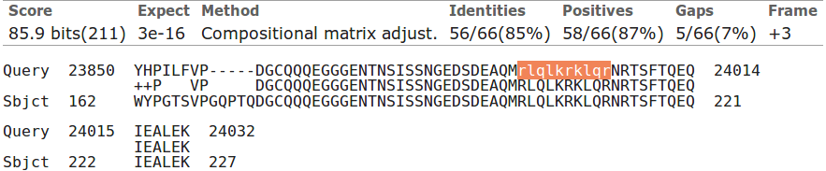
The second (to be found much further down your blast Alignments output) is comprised entirely of Arginines, Luecines and Lysines and Glutamines, the 10 residues between 203 - 212.

UniprotKB also suggests there are two compositionally biased regions.
Well, hardly an exact match, but there is approximate agreement? One would certainly suppose that blast is only willing to mask fairly severe cases of compositional bias. It is also probable that blast has a rather more mechanistic (i.e. non-biological) interpretation of what computational bias is?
SMART also predicts the more obvious region of computational bias, rather more generally:
“An octapeptide and/or a homeodomain can occur C-terminal to the paired domain, as well as a Pro-Ser-Thr-rich C-terminus”
Not important points in themselves of course, the real message of the exercise is that you can discover so much by either:
Looking things up in databases
or:
Using the simple analytical software tools yourself.

DPJ – 2017.10.15

megablast is a less sensitive but even faster version of blast only suitable when, as now, almost identical matches are sought.
By default, megablast uses Linear Gap Costs. That is, it just multiplies the size of the gap with the Mismatch penalty. The other two algorithms employ the more common Affine strategy, using Existence and Extension penalties. For more about Gap Penalties, go here.
This filter avoids finding “hits” supported only by matches in regions not specific to the query. For example, a polyA tail cannot help to identify a specific mRNA as it is present is all mRNAs. The use of this filter will be evident when we look at the blast output.
If you have any non-default settings, they should be highlighted in yellow.
Or you could just read the textual list that follows the graphic if you wish to insist on the simplistic.
Actually, I see now it is a single exon of the PAX6-AS1 entity pursued so vigorously in the last exercise. Those of you foolish enough to read all the ramble of my answers to questions will recall PAX6-AS1 with glee! Yep … ignore it.
To use a global approach would be to imply that you were only interested in database entries that matched your query sequence from end to end. Generally, this is not true. You would usually be interested in a database sequence that was similar over any significant region.
Why not try them? End up with the alignments for the top hit in E value order.
Here I will assume we have talked about these parameter and you are reasonably well informed of the issues.
2 base pairs (Sbjct: 999-1000, AG) occur in both the first two matches illustrated. 6 base pairs are shared between the 2nd and 3rd matches (Sbjct: 1081-1086, CAGGTA).
That I did not ask, because I only just thought of it.

